3/17/2021

Nadir Hussain

023-18-0025

Computer Networks

Lab 05

**Lab Objectives:**

* ***Understand the Link layer protocols: STP and RSTP, why STP is needed? Why to use RSTP?***
* ***Practice multiple LAN segments, communicate between PCs using Switches, capture the data using Wireshark.***
* ***Understand the loop caused by network design, how to resolve it.***
* ***Understand the roles of bridges and ports***
* ***Understand the states of ports, how to configure the ports.***
* ***How to make root among multiple switches.***
* ***Practice the same task with RSTP.***

**Understand the Link layer protocols: STP and RSTP, why STP is needed. Why to use RSTP?**

**STP:** Spanning tree protocol, used to find the minimum cost to send

We need STP for 2 reasons.

1. MAC address Instability
2. Broadcast strong

**MAC address Instability:**

When PCs are added and removed to LAN, then IP to MAC address is updated every time by ARP (Address Resolution protocol).

**Broadcast strong:**

When there is a loop between the switches.

**RSTP:**

STP takes more than 30 seconds and more than 50 seconds for conversion of roles of ports when

RSTP reduces the conversion time by half as compare to STP.

Stp mode rstp is the command to apply rstp protocol for conversion.

**Practice multiple LAN segments, communicate between PCs using Switches, capture the data using wireshark**

**LAN Design**

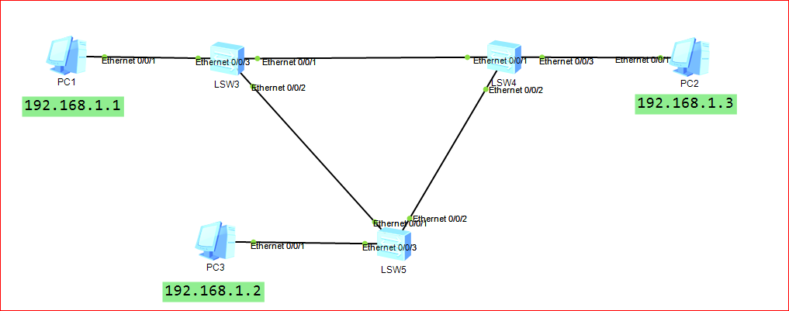

**Ping From PC3 to PC1**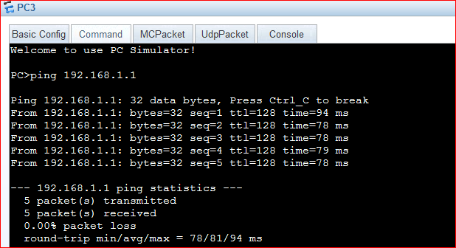

**Meanwhile at wireshark we can observe**

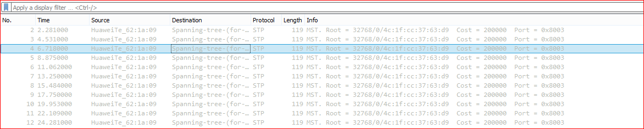

**STP is active, as we have used switch.**

***Understand the loop caused by network design, how to resolve it.***

We can observe the loop in following network design.

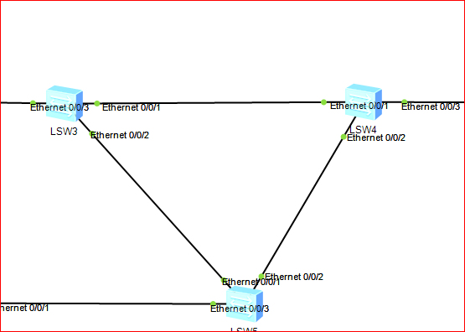

We can see in the network design we are facing a kind of loop among switches. It causes waste of resources so we need to resolve it.

**There are two ways we can resolve.**

* Removing the edge from one Switch to another, physically. Which is impractical and in efficient.
* Shutting down the switch ports logically, these ports were causing loops and redundancy. We use STP for this.
* Switches use STP protocol to resolve the loop and redundancy issue automatically.

Vertices are end systems, wires are edges. We need to decide which switch is root?

There is a mechanism to make some switch as root. In distributed systems, we decide the switch as root by looking into the majority of connections to it.

**BPDU:**

Bridge protocol data unit, one bridge shares its data to other, letting others know whether it is leaf , root or other. It contains path cost as well.

**Understand the roles of bridges and ports**

A bridge can be either a root or non root.

Ports on switch can either be root, designated or alternate.

**Root port:**

The port which connects a switch with root node is called root port.

**Designated port:**

Port at root node that is used to send message to child nodes.

We don’t allow 2 designated ports, because it causes loop. So we make it ***alternate*** port.

To define the one of three roles, each port has ***port id.***

**Understand the states of ports, how to configure the ports.**

Before assigning roles, port can be in one of five states.

1. Disabled:
2. Forwarding
3. Blocking: When port is shut down
4. Listening: When port is on and is listening
5. Learning: When it reads packet and updates itself

Disbled: Port can’t read or listen anything.

Blocking:It listens BPDU, but blocks them.

**Configuring the port.**

We can shutdown or trun on a particular port on particular switch.

***Int eth0/0/1***

***Shutdown //shut***

If we again want to make On some port

***Undo shut***

**Root Path cost:** The cost of path followed from Root to any node. Root has 0 RPC.

**How to make root among multiple switches.**

How a root is decided among multiple switches.

* Whose First 5 or 4 digit number is greater than other switches, becomes root.
* If 2 switches has equal prefix number, then we check

**To know which switch is root and which is non root.**

Display stp table of all switches then compare the CIST root/ERPC:

If CIST and CIST root are same then that switch is root.

Output:

Disp stp

Note down CIST bridge number and Port role.

We can manually make one switch as Root, we change the priority of that switch to make it root.

Use command

Stp priority 4096 //Which is the factor to increase or decrease the priority, we make other switches as less prioritize

Priority starts from 0 and is addition of 4096 to previous number and add it 16 times which is maximum.

Exp:

0

4096

4096*2

4096*3

…

….

Now we define the roles of ports, i.e root, designated or alternate

Stp pathcost-standard

Start ping from PC1 to PC3 with –t

We can make shut down any port

By

It will start after a few seconds if it was the path of ping.

**Task:**

**Design a network containing loop, use STP to display the ports on each switch. Change the role of port and display the port roles. Run ping command and block the port to observe result.**

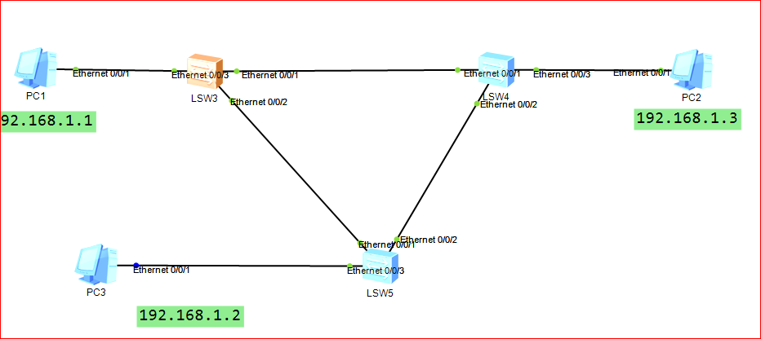

On LSW3

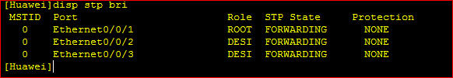

So LSW3 is not a root switch, because it contains a port that refer to root switch.

On LSW4

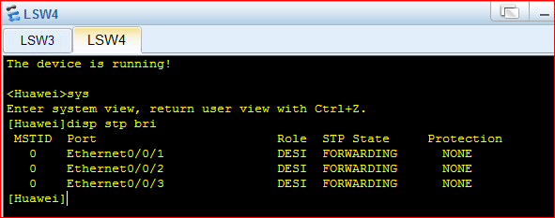

LSW4 is root as it does’t refer to any root.

On LSW5

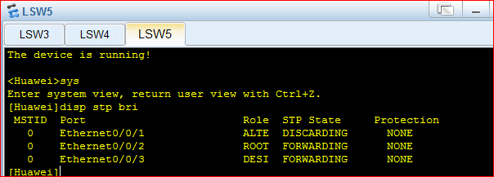

LSW5 is also not a root.

So we can say LSW3 is the root bridge, made by STP.

Or we can also check as

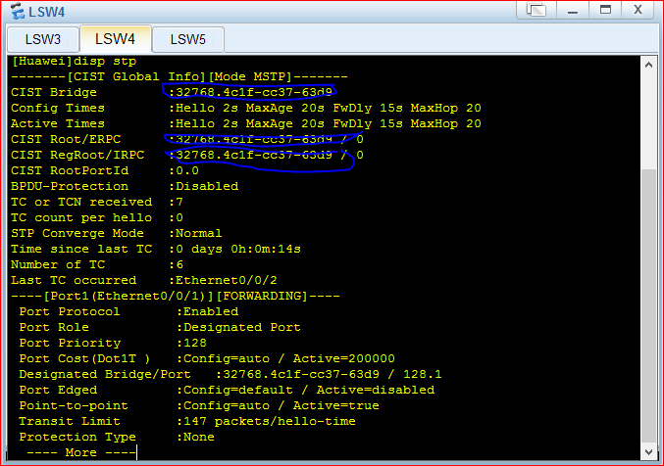

Are same ids.

Ping from PC1 to PC2

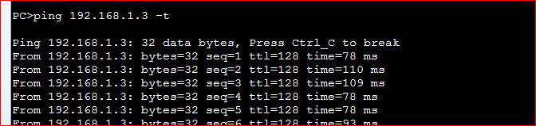

Now block the ethernt 0/0/1

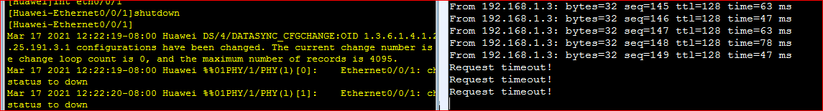

We can observe timeout response from ping. Which means eth0/0/1 is root.

After sometime, eth 0/0/2 will become the root and message will travel.

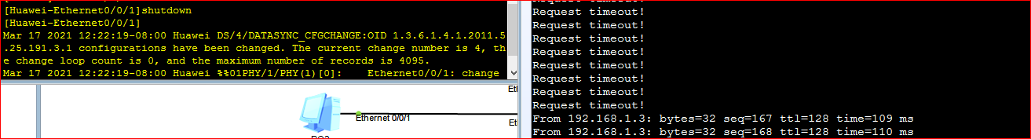

Now we block eth0/0/2 as well

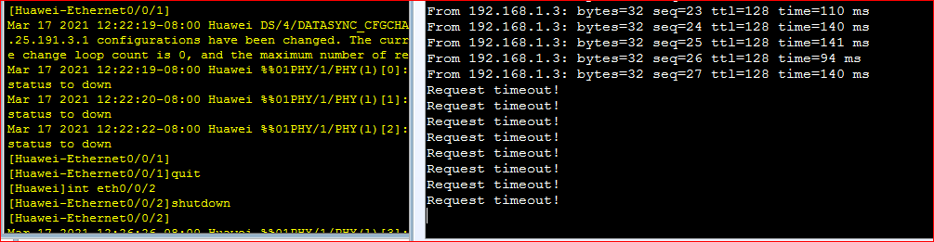

Now PC1 can’t ping PC2 anyway.

We unblock eth0/0/1



And we observed, almost after 50 seconds it started again.

**Change the root from LSW4 to LSW3 i.e from Switch 4 to switch 3**

**Initially We have**

**LSW3 as**

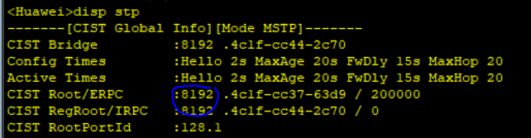

**LSW5 as**

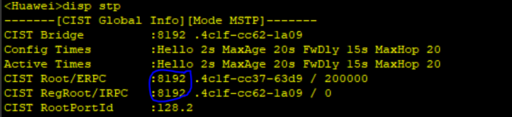

**And LSW4 as**

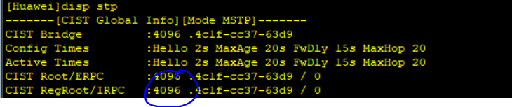

**The root has lowest value of priority. i.e to make LSW3 as root, we set its priority value 4096, and increase for other switches.**

**For LSW3**

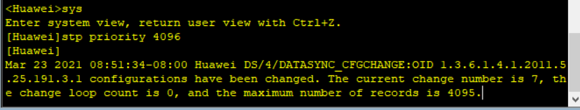

**And we increase for LSW4**

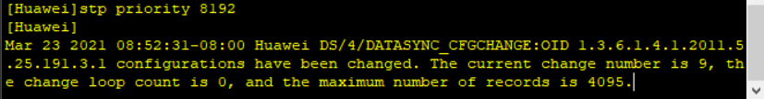

**Now we check if LSW3 has become root switch?**

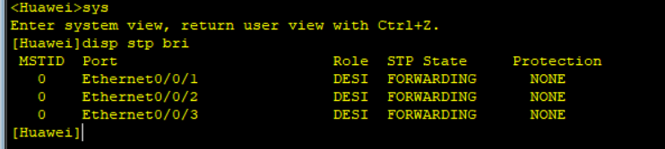

**Yes it has became the root.**

**In similar way we can make a port as root or designated or alternate.**

**Practice the same task with RSTP.**

**We need to change the mode at first.**

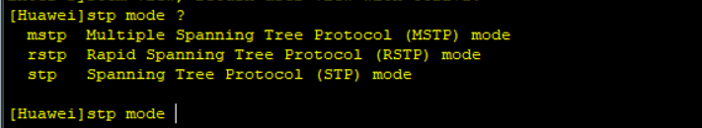

**Are available modes.**

**At LSW3 or switch3 we change the mode**

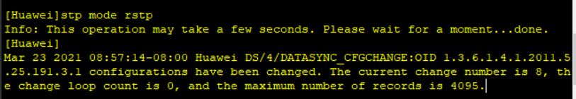

**At LSW4 or switch4 we change the mode**

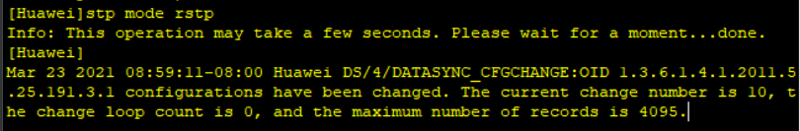

**At LSW5 or switch5 we change the mode**

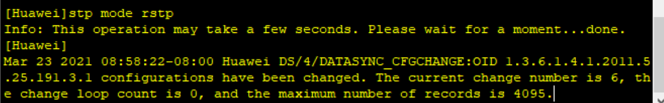

**Now we can operate the same commands to use rstp, which will take a much less time to switch roles, block or unblock ports etc.**

**Let’s ping from PC3 to PC2 by -t command and block the port.**

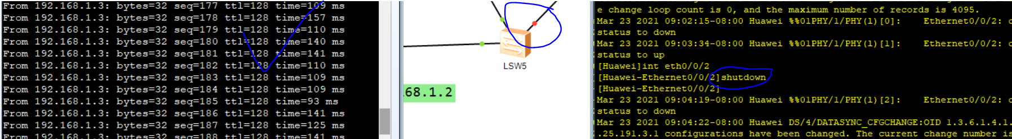

**The port has been blocked but ping is still getting reply. Let’s block another port as well.**

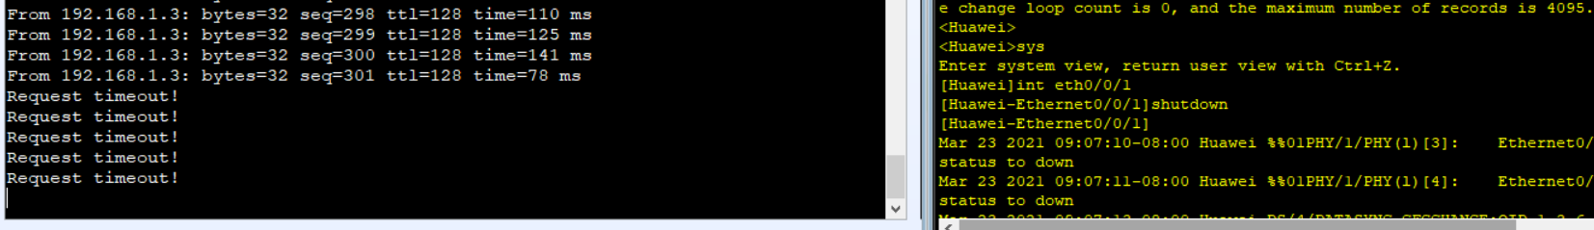

**Now it shows time out. It did not took time to block the ports. Let’s unblock both ports and observe the time taken by rstp.**



**And it started again in very less time.**

**The END**